**Design Report**

202151075008

**1. Introduction**

This design report presents a plan for addressing the challenges identified in the analysis of indoor localization using agent-based solution. The goal is to develop an efficient and accurate indoor localization system by leveraging agent-based solution principles and techniques. This report outlines the overall design approach, discusses the incorporation of small solutions into a broader solution, and provides a UML-based model representing the planned solution.

**2. Design Approach**

The design approach for the indoor localization system with agent-based solutions involves the following steps:

**2.1 Problem Analysis**: Analyze the specific requirements, challenges, and constraints of indoor localization. This includes understanding the complexities of indoor environments, sensor integration, signal interference, variability, and scalability.

**2.2 System Modeling**: Create a comprehensive model using UML to represent the structure, behavior, and interactions of the indoor localization system. The model will encompass various components, including the dataset, sensor integration, signal processing, localization algorithms, and user interface.

**2.3 Abstraction and Refinement**: Utilize abstraction techniques to simplify the model and separate concerns. Identify relevant MDE concepts, such as metamodels, models, and transformations, to capture system requirements and facilitate model-driven development.

**2.4 Agent-Based Development**: Employ agent-based development techniques to generate system artifacts automatically from the models. This includes generating code, configuration files, and documentation based on the defined models.

**2.5 Iterative Development**: Follow an iterative development process, allowing for continuous refinement and improvement of the system. Each iteration involves refining the models, implementing the changes in the code, and validating the system's performance through simulations and real-world testing.

**3. Small Solutions and Overall Solution**

To address the challenges identified in the analysis, the following small solutions will be incorporated into the overall solution:

**3.1 Sensor Integration**: Develop modules for integrating data from various sensors such as Wi-Fi, Bluetooth, magnetic field sensors, or inertial sensors. Implement algorithms for data fusion, synchronization, calibration, and compatibility to handle sensor heterogeneity effectively.

**3.2 Signal Processing**: Design robust signal processing techniques to address signal interference, multipath propagation, and non-line-of-sight conditions. Develop models and algorithms to accurately simulate signal behavior, interference sources, and optimize localization accuracy.

**3.3 Dataset Management**: Create a dataset management module to handle data collection, preprocessing, and calibration. Implement functionalities for data filtering, interpolation, and storage to ensure accurate and reliable data for training and testing the localization algorithms.

**3.4 Algorithm Selection and Optimization**: Evaluate and select appropriate localization algorithms, such as K-Nearest Neighbors (KNN), Decision Trees, or Support Vector Machines (SVM), based on the specific requirements and performance metrics. Optimize the chosen algorithms for accuracy, precision, and scalability.

The small solutions will be integrated into the overall solution by incorporating them as components within the UML model. The components will have defined interfaces and relationships, ensuring seamless integration and collaboration among the various modules.

**4. UML Model**

The UML model represents the planned solution for indoor localization using MDE. It includes the following components:

**4.1 Dataset:** Represents the dataset used for training and testing the localization algorithms. It includes attributes for data storage, preprocessing methods, and data manipulation functions.

**4.2 Sensor Integration**: Represents the module responsible for integrating data from different sensors. It includes components for sensor fusion, synchronization, calibration, and compatibility management.

**4.3 Signal Processing**: Represents the module for processing the collected signals. It includes components for signal filtering, propagation modeling, interference handling, and optimization techniques.

**4.4 Localization Algorithms**: Represents the various localization algorithms considered for indoor positioning. It includes components for KNN, Decision Trees, SVM, or other selected algorithms, along with optimization and evaluation methods.

**4.5 User Interface**: Represents the user interface components for interacting with the system. It includes components for visualization, user input, and system feedback.

**4.6 System Management**: Represents the overall system management components, including configuration management, system monitoring, and performance evaluation.

**5. Meta-Model Discussion**

The chosen technology for implementing the indoor localization system with agent-based approach is based on the Unified Modeling Language (UML). UML provides a standardized notation for expressing the system's structure, behavior, and relationships, making it suitable for capturing and communicating the design of the indoor localization system.

The UML meta-model consists of concepts such as classes, associations, inheritance, interfaces, and dependencies. These concepts allow for defining the structure of the system, specifying behavior through methods and operations, and establishing relationships between the components.

By utilizing UML as the meta-model, the design of the indoor localization system can be effectively represented and communicated. The UML diagrams, including class diagrams, activity diagrams, and sequence diagrams, can be used to capture different aspects of the system's design and facilitate the implementation process.

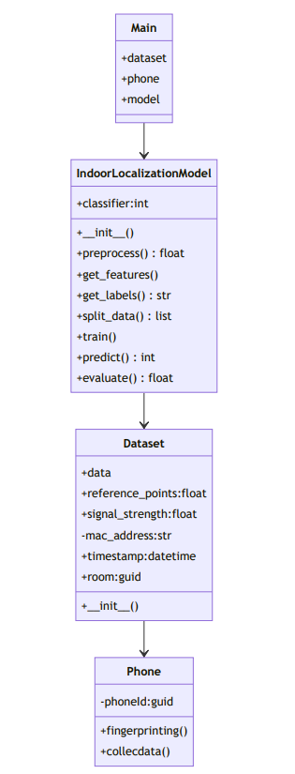

Figure 1. UML Model of the system.

**6. Indoor Localization System**

* The process starts with the Phone.
* The Phone interacts with the Application.
* The Application performs Fingerprinting:
* The Application collects data from various sensors such as Wi-Fi, Bluetooth.
* The collected data is used to create a fingerprinting radio map, which captures the signal characteristics in different locations within the indoor environment.
* The Fingerprinting Data is then Preprocessed:
* The collected data is preprocessed to filter noise, handle missing values, and normalize the signal strengths.
* Preprocessing techniques such as data filtering, interpolation (to avoid missing values between timestamps), and signal quality assessment are applied to ensure the accuracy and reliability of the fingerprinting data.
* Location Estimation is performed based on the preprocessed data:
* The preprocessed data is used as input to localization algorithms such as K-Nearest Neighbors (KNN), Decision Trees, Support Vector Machines (SVM), or other selected algorithms.
* These algorithms analyze the fingerprinting data and estimate the location of the Phone within the indoor environment based on the similarity between the observed signal patterns and the stored fingerprinting radio map.
* The estimated location is then Sent Back to REST API server:
* The estimated location is communicated back to the Application from the localization algorithms.
* The estimated location may include coordinates or other identification information representing the Phone's position within the indoor environment.
* The Server receives the location data:
* The Server processes and stores the received location data.
* The server may perform additional operations on the location data, such as aggregating it for analytics purposes or storing it for future reference.
* Finally, the location data is sent back to the Phone:
* The processed location data is transmitted back to the Phone or the Application.
* The Phone or Application can use this information for various purposes, such as displaying the estimated location on a map or triggering location-based actions.

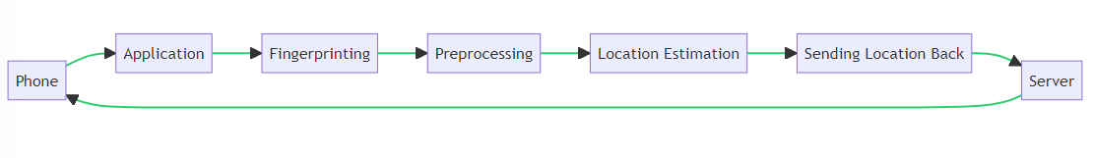

Figure 2. Indoor Localization System.

**7. Conclusion**

This design report has presented a plan for addressing the challenges of indoor localization using agent-based approach. The design approach involves problem analysis, system modeling, abstraction, model-driven development, and iterative development. Small solutions have been identified to address the specific challenges, and a UML-based model has been presented to represent the overall solution. The chosen technology, UML, provides a standardized meta-model for expressing the system's design, facilitating communication and implementation.

By following this design plan, it is expected that the indoor localization system will benefit from the systematic and structured approach of agent-based solutions, resulting in an efficient and accurate solution for indoor positioning.